General Biology Year 11

Unit 2 – Solving problems to survive

Task 7: Practical – Gas exchange in animals

|  |  |  |  |
| --- | --- | --- | --- |
| **Name:** | **Teacher:** | **Date:** | **Score:**  / **21** |

**Assessment type:** Science Inquiry - Practical

**Conditions**

Time for the task:

* **One hour in class assessment** – Dissect fish gills and make comparisons with a rat’s lungs.

**Task weighting** – 5%

______________________________________________________________________________

**Introduction:**

With few exceptions, oxygen is a requirement of most living things. Oxygen is a reactant in the process of aerobic respiration.

**glucose + oxygen → carbon dioxide + water + usable energy**

Animals use different mechanisms to obtain oxygen from their environment. The respiratory system is a system by which oxygen is obtained from the environment and brought into close contact with the cells or a transport system.

**Aim -** In this activity you will compare the way a fish and a rat obtain oxygen from the environment.

**PART A:** **The fish**

1. The fish you will examine is described as a ‘bony’ fish. Examine the external structure of the head of the fish. Identify the structures shown in the diagram below. Locate the **operculum**, lift it and look at the gills.



What do you think is the function of the operculum? (1 mark)

__________________________________________________________________________________________________________________________________________________

1. Cut out a small piece of gill and float it in a petri dish of water.

Describe what happened when you floated the piece of gill in the water? (1/2 mark) __________________________________________________________________________________________________________________________________________________

What does this tell you about the structure of the gill? (1 mark)

__________________________________________________________________________________________________________________________________________________

1. With the **operculum** open, insert a blunt probe into its opening and determine where the cavity ends.

What **colour** were the gills of your fish? Suggest a **reason** for this colour. (1 mark)

__________________________________________________________________________________________________________________________________________________

1. Refer to the fish video on the board. Observe a goldfish in a **fish tank**.

Describe the movement of the mouth and the operculum. (1 mark)

__________________________________________________________________________________________________________________________________________________

When the fish closes it mouth, where does the **water** go? (1/2 mark)

__________________________________________________________________________________________________________________________________________________

1. Remove a single gill. Examine the gill under a hand lens or binocular microscope to see the structure in more detail.

Draw a **labelled diagram** of **one gill** of a fish in the box below. (3 marks)

1. Why do you think fish have **numerous flattened epithelial surfaces** (gill filaments)?

(1 mark)

__________________________________________________________________________________________________________________________________________________

1. Describe how gills absorb oxygen and disperse carbon dioxide. (2 marks)

____________________________________________________________________________________________________________________________________________________________________________________________________________________________________________________________________________________________________

**PART B:** **The rat**

1. Study the rat dissection pictures below and answer the questions that follow.



The most obvious organs will be the heart and the lungs. Examine the lungs. Lungs in a living rat or freshly killed specimen would be bright red and have a spongy texture.

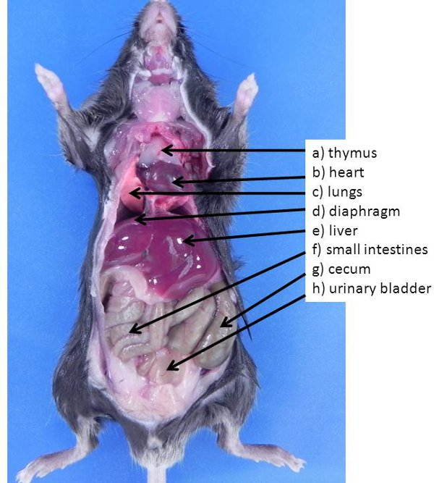

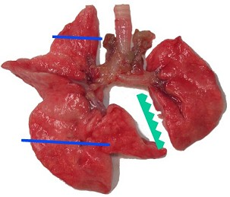

**Questions**

1. Often the lungs of mammals look like two balloons. Does this **description fit the shape** and structure of the rat’s lungs? Describe the structure of the lungs. (2 marks)

___________________________________________________________________________________________________________________________________________________________________________________________________________________________

1. The lung tissue is made up of tiny air-filled sacs, the alveoli with walls which are one cell thick. Oxygen inhaled by the rat passes across these walls into blood capillaries.

Draw a **labelled diagram** of the lungs of a rat in the box below. (2 marks)

right lung left lung trachea bronchi

1. What do you think is the **function** of the trachea? (1 mark)

__________________________________________________________________________________________________________________________________________________

1. The interior surface of the trachea is **spongy-looking**. This is due to the lining of the trachea, which consists of column-shaped cells which secrete **mucus** (slippery secretion) and have many **cilia** (hair like structure) along their surface (see diagram below).

1. Suggest a **function** for the **cartilage** in the **trachea**. (1 mark)

__________________________________________________________________________________________________________________________________________________

1. What is the function of the **cilia**? (Hint – they beat upwards). (1 mark)

__________________________________________________________________________________________________________________________________________________

1. Complete the table below. (3 marks)

|  |  |  |
| --- | --- | --- |
|  | **Fish** | **Rat** |
| **Air enters the body via . . .** | the mouth |  |
| **Exchange of oxygen occurs across the . . .** | gill plates |  |
| **Is the respiratory surface moist?** |  | yes |
| **The surface of the respiratory is increased by . . .** |  |  |
| **Increased oxygen flow across the respiratory surface is assisted by . . .** |  | breathing |

**END OF ASSESSMENT**